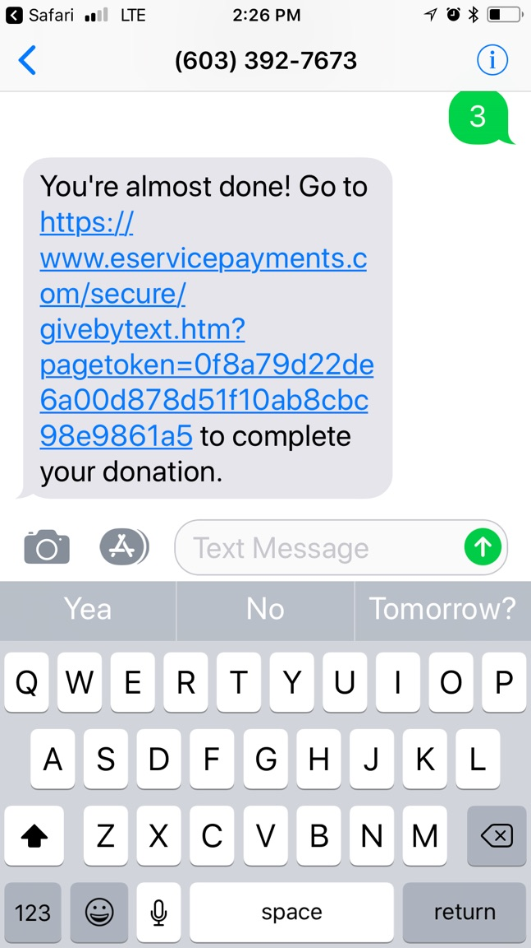

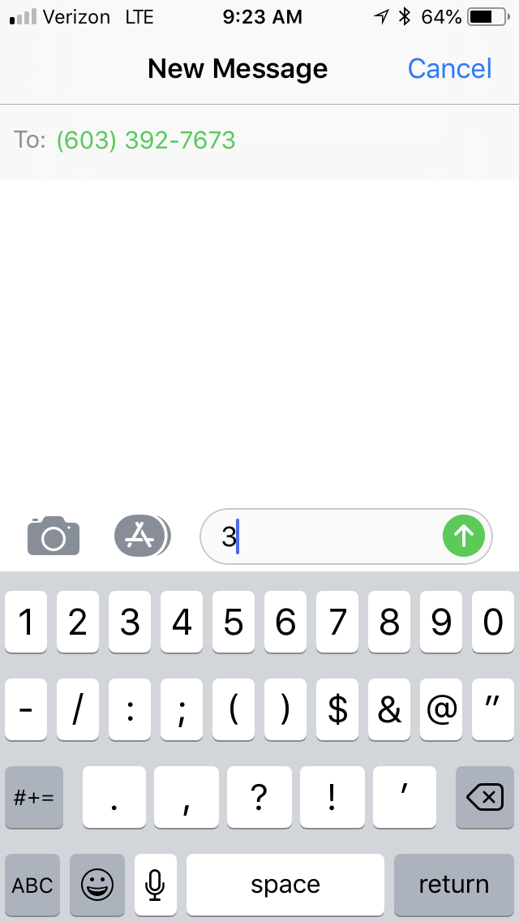

Step 1: Start a new text and Enter Rock Text Giving phone number:   
**603 392 7673**

Step 2: Enter amount number in message box ($3 is the minimum donation) CLICK **Send** button

The first time you use this service you’ll need to CLICK the provided link to visit our payment partner Vanco’s page to sign-up and add a funding source.

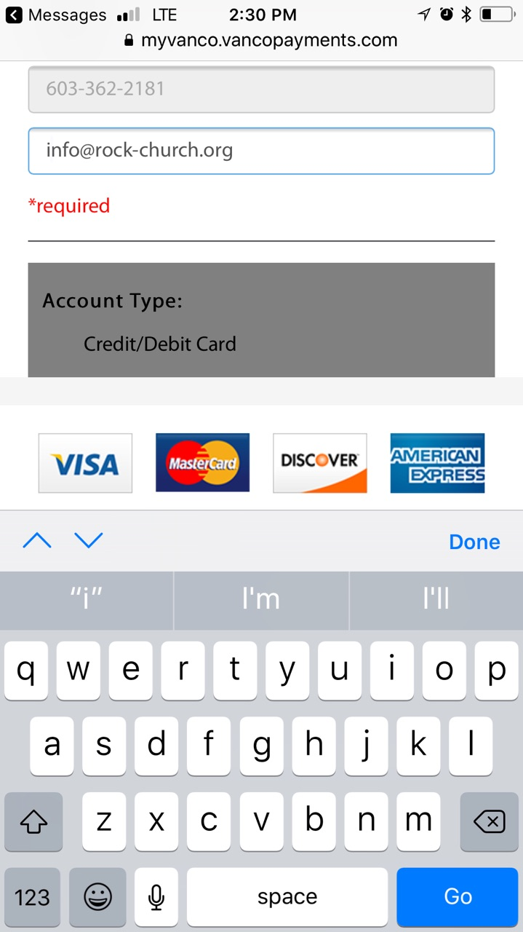

Step 3: Fill in your information and choose your account type and account numbers. *Please make sure you use the address associated the credit card or bank account you are entering as you funding source.

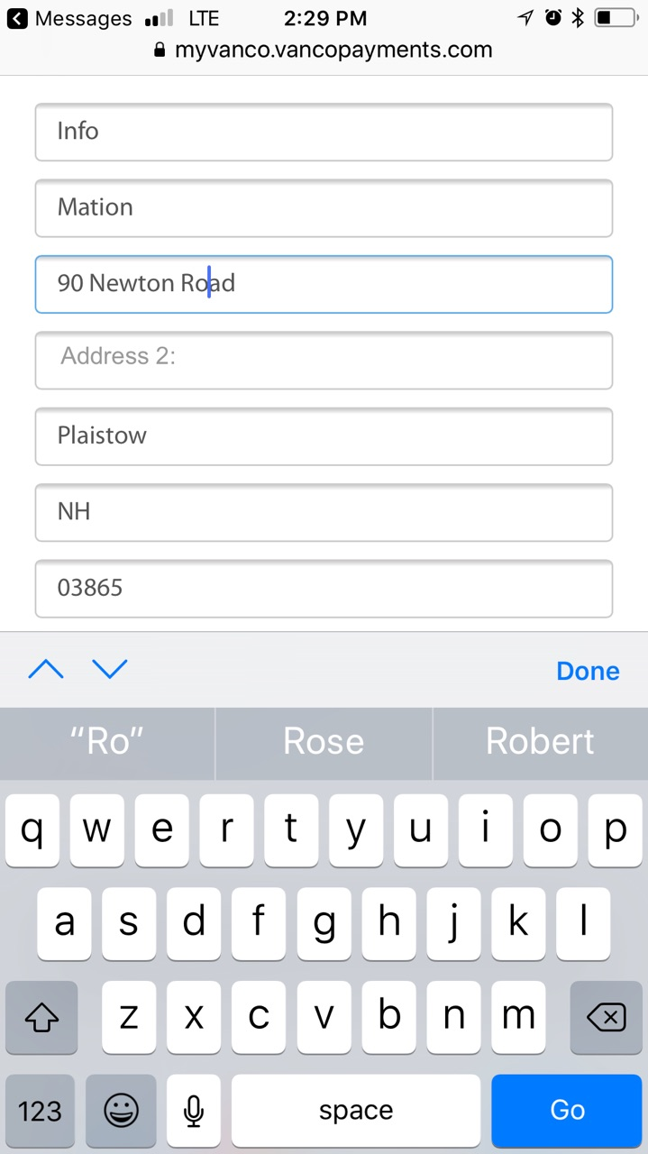

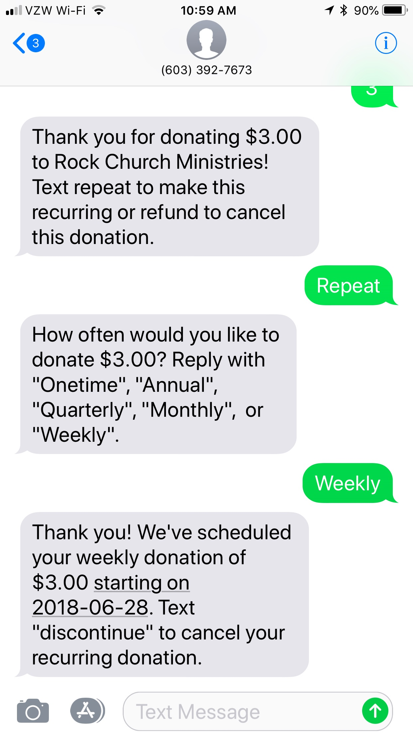

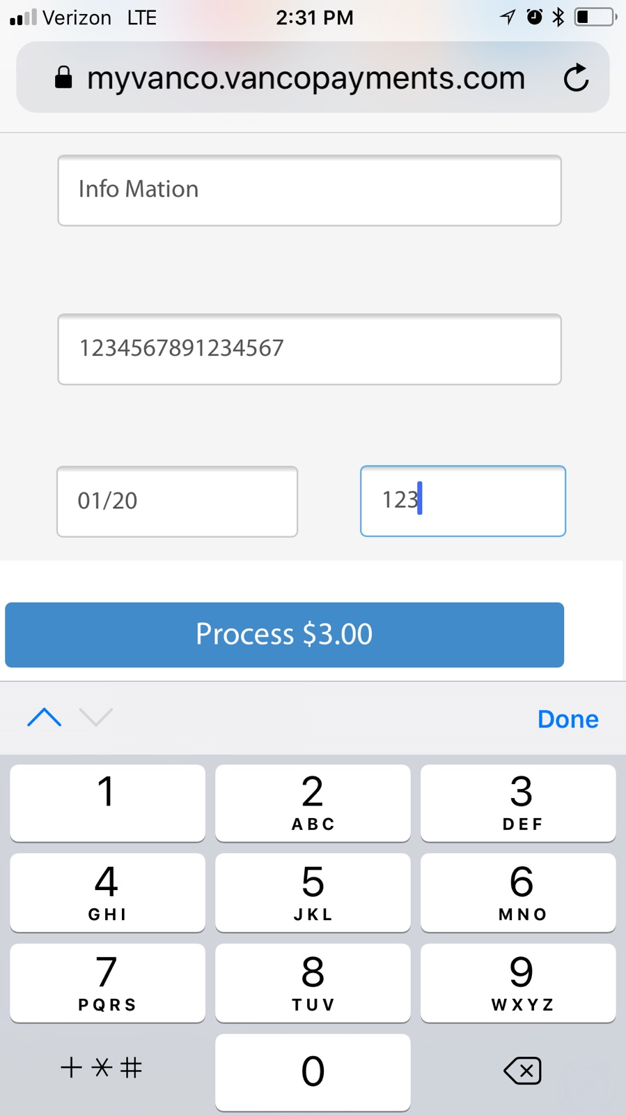

Please enter your 16 digit Credit or Debit card number, the expiration date (MM/YY) and the 3 digit CSV code on the back of your card. Then CLICK **Process** to complete your transaction.

You’ll receive a Thank you text confirmation and have the opportunity to make your Donation recurring by texting **Repeat** and then texting afrequency option such as **Weekly** etc**.**

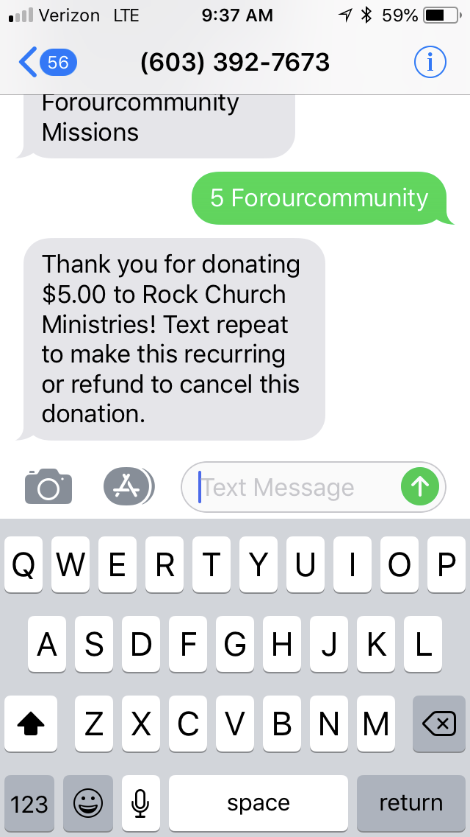

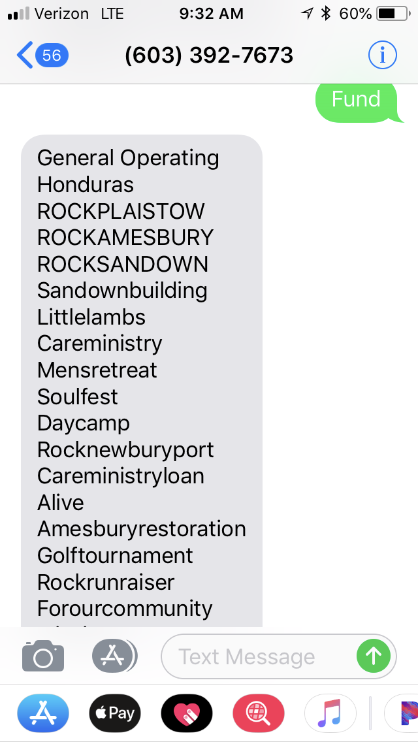

You can also make payments or donations to particular categories or events by texting **Fund** for a list of available options. To make a transaction **Text the amount and name of fund.** For example you can  
text **5 Forourcommunity** and you’ll make a donation or payment directly to that fund at Rock Church.